6.For each event plan, list the plan number, count of the event plan lines, and sum of the number of resources assigned. For example, plan number “P100” has 4 lines and 7 resources assigned. You only need to consider event plans that have at least one line.

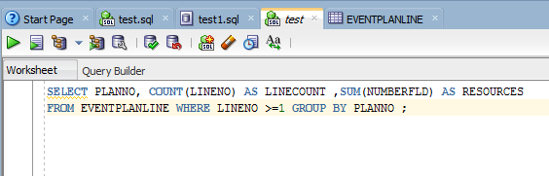

SELECT PLANNO, COUNT(LINENO) AS LINECOUNT ,SUM(NUMBERFLD) AS RESOURCES FROM EVENTPLANLINE WHERE LINENO >=1 GROUP BY PLANNO ;

